Lab - View Wired and Wireless NIC Information

Objectives
Part 1: Identify and Work with PC NICs
Part 2: Identify and Use the System Tray Network Icons

Background / Scenario
This lab requires you to determine the availability and status of the network interface cards (NICs) on the PC that you use. Windows provides a number of ways to view and work with your NICs.
In this lab, you will access the NIC information of your PC and change the status of these cards.

Required Resources
- 1 PC (Windows with two NICs, wired and wireless, and a wireless connection)
Note: At the start of this lab, the wired Ethernet NIC in the PC was cabled to one of the integrated switch ports on a wireless router and the Local Area Connection (wired) was enabled. The wireless NIC was disabled initially. If the wired and wireless NICs are both enabled the PC will receive two different IP addresses and the wireless NIC will take precedence.

Instructions

Identify and Work with PC NICs.
In Part 1, you will identify the NIC types in the PC that you are using. You will explore different ways to extract information about these NICs and how to activate and deactivate them.
Note: This lab was performed using a PC running on the Windows 10 operating system. You should be able to perform the lab with one of the other Windows operating systems listed; however, menu selections and screens may vary.

Use the Network and Sharing Center.
      - Navigate to the Control Panel. Click View network status and tasks under Network and Internet heading in the Category View.
      - In the left pane, click the Change adapter settings link.
      - In the Network Connections window, the results provide a list of NICs available on this PC. Look for your Wi-Fi adapters.
Note: Virtual Private Network (VPN) adapters and other types of network connections may also be displayed in this window.

Work with your wireless NIC.
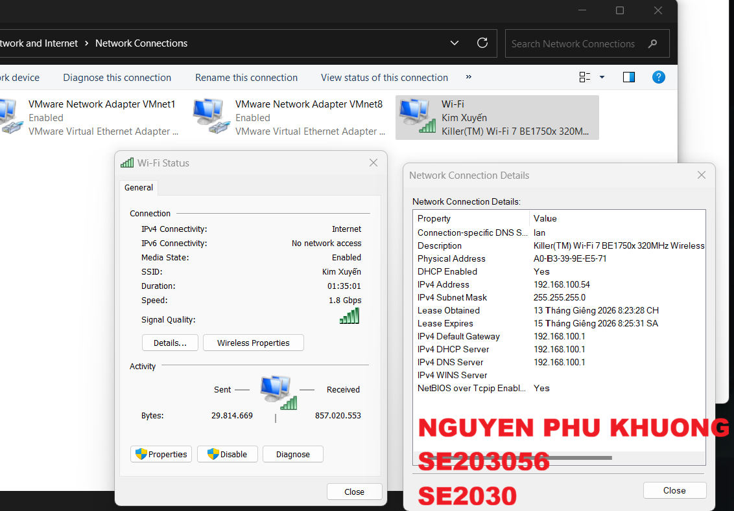
      - Locate the wireless network connection. If it is disabled, right-click and select Enable to activate your wireless NIC.
      - If the wireless network connection is not currently connected, right-click and select Connect/Disconnect to connect to an SSID that you are authorized to connect to.
      - Right-click a wireless network connection, and then click Status.
      - The wireless network connection Status window displays where you can view information about your wireless connection.

Questions:
What is the Service Set Identifier (SSID) for the wireless router of your connection?
Kim Xuyến
What is the speed of your wireless connection?
1.8Gbps.
      - Click Details to display the Network Connection Details window.

Questions:
What is the MAC address of your wireless NIC?
A0-B3-39-9E-E5-71.
Do you have multiple IPv4 DNS Servers listed? If so, why would multiple DNS Servers be listed?
NO.
Multiple DNS Servers are listed in case the first DNS server becomes unresponsive. Reasons may include the server is down for maintenance or is experiencing a problem. If the first DNS server does not respond, then the second DNS Server is used, and so on.

      - Open a Windows Command Prompt and type ipconfig /all.
Open a Windows Command Prompt.
Notice that the information displayed here is the same information that was displayed in the Network Connection Details window in Step e.
      - Close the command window and the Network Connection Details window. This should return you back to the Wi-Fi Status window. Click Wireless Properties.
Close a Windows Command Prompt.
      - In the Wireless Network Properties window, click the Security tab.
      - The type of security the connected wireless router has implemented displays. Click the Show characters check box to display the actual Network security key, instead of the hidden characters, and then click OK.
      - Close the Wireless Network Properties and the Wi-Fi Status windows. Select and right-click the Wi-Fi option > Connect/Disconnect. A pop-up window should appear at the bottom right corner of your desktop that displays your current connection, along with a list of SSIDs that are in range of the wireless NIC of your PC. If a scrollbar appears on the right side of this window, you can use it to display additional SSIDs.
      - To join one of the other wireless network SSIDs listed, click the SSID that you want to join, and then click Connect.
      - If you have selected a secure SSID, you are prompted to enter the Security key for the SSID. Type the security key for that SSID and click OK. You can click the Hide characters check box to prevent people from seeing what you type in the Security key field.

Work with your wired NIC.
      - On the Network Connections window, select and right-click Ethernet option to display the drop-down list. If the NIC is disabled, enable it, and then click the Status option.
Note: You must have an Ethernet cable attaching your PC NIC to a switch or similar device to see the status. Many wireless routers have a small 4-port Ethernet switch built-in. You can connect to one of the ports using a straight-through Ethernet patch cable.
      - In the Status window, the results display information about your wired connection to the LAN.
      - Click Details… to view the address information for your LAN connection.
      - Open a command window prompt and type ipconfig /all. Find your Ethernet adapter information and compare this with the information displayed in the Network Connection Details window.
Open a Windows Command Prompt.
C:\Users\ITE> ipconfig /all
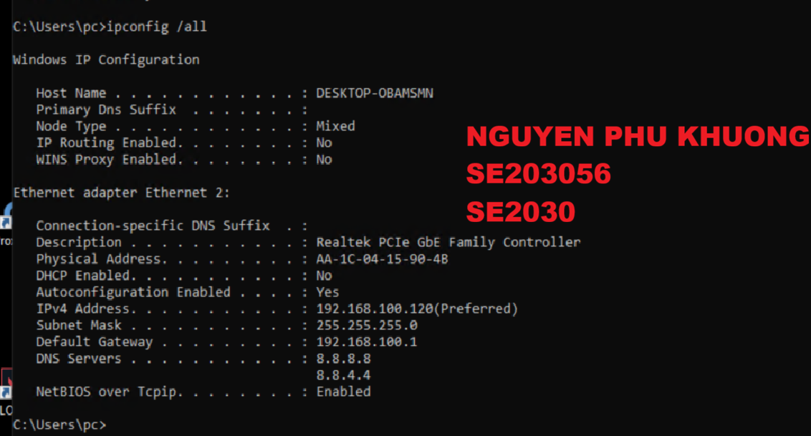

Close a Windows Command Prompt.
      - Close all windows on your desktop.

Identify and Use the System Tray Network Icons
In Part 2, you will use the network icons in your system tray to determine and control the NICs on your PC.

Use the network icon.
      - Click the system tray. Click the network icon to view the pop-up window that displays the SSIDs that are in-range of your wireless NIC.
      - Click Network & Internet.
      - In the Settings windows, click Change adapter options under the Change your network settings heading.
      - In the Network Connections window, right-click Wi-Fi and select Disable.
      - Examine your system tray. Click the Network icon again. With the Wi-Fi disabled, wireless networks are no longer in range and not available for wireless connections.
      - You can also disable the Ethernet network by disabling the Ethernet adapters.
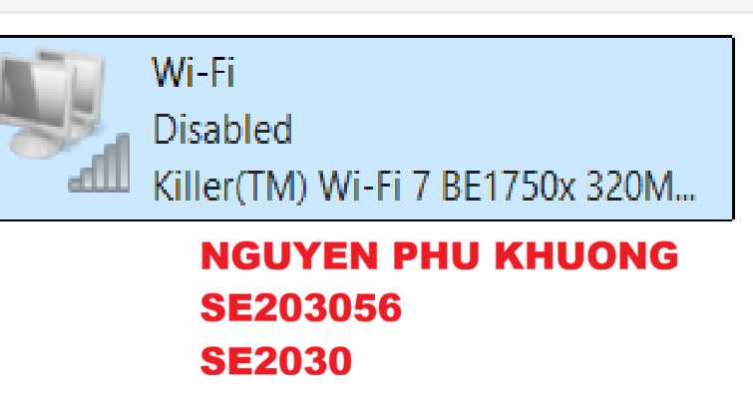

Identify the Network Problem icon.
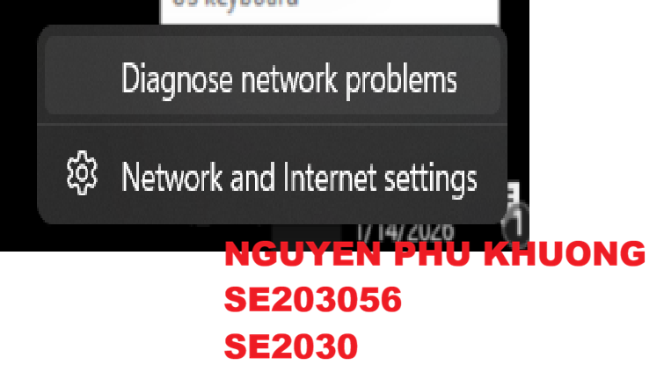
      - In the Network Connections window, disable all the Wi-Fi and Ethernet adapters.
      - The system tray now displays the Network Disabled icon, which indicates that network connectivity has been disabled.
      - You can click this icon to return to the Network and Internet settings.
      - In the Network and Internet settings window, you can click Troubleshoot to use the PC to resolve the network issue for you.
      - If troubleshooting did not enable one of your NICs, then you should do this manually to restore the network connectivity of your PC.
Note: If a network adapter is enabled and the NIC is unable to establish network connectivity, then the Network Problem icon appears in the system tray.
If this icon appears, you can troubleshoot this issue just like you did in Step 2c.

Reflection Question
Why would you activate more than one NIC on a PC?
Multiple NICs can be used if more than one path is needed for the PC. One example of this would be if the PC is being used as a Proxy Server.
End of Document

